# COMP 3023 Assignment 2

# Calculate the patient alert levels

Figure 1: Strategy Design Pattern

**Design Pattern:**  Strategy Design Pattern

The system must be able to utilise the correct algorithm to calculate a patient’s alert level depending on their primary disease. To address this, I chose to utilise the strategy design pattern, which would make it so that each disease alert level algorithm were interchangeable

This design is represented in Figure 1. The AlertCalcStrategy is the common interface that all the algorithms inherit from. This class is used by the AlertCalcContext, which sets and executes the chosen algorithm.

**How it works:**

1. A patient is selected to have new vitals declared for by the user
2. The PatientManagementSystem calls the addVitals() method for the selected patient, passing in a the new vitals class and a boolean set to true
3. The addVitals() method adds the inputted vitals to the patient
4. The status of the inputted Boolean is then checked, if true, addVitals() will set a new alert for the patient based on the inputted vitals by calling the function
5. The alertCalc context and the specific diagnosis’s alert calculation classes are defined
6. The patients primaryDiagnosis is checked, addVitals() calls the setStrategy() function from the context, passing in a reference to the diagnosis strategy
7. After the context is set, addVitals() calls the executeStrategy() function from the context, passing in a reference to itself (a reference to the patient)
8. AlertCalcContext calls the calculateAlert() function from the strategy, which is inherited from the AlertCalcStrategy.
9. The specific strategy checks the vitals, and then calls setAlertLevel() from the inputted patient, passing in the chosen AlertLevel.

**Git commits:**

* I first implemented the strategy in commit ccb3514
* I then implemented the context for the strategy in commit 12c58f7
* I implemented the calculation for the strategies in commit d34278d
* I had a working finished FR1 in commit d653330
* Other commits: f0f93a3, e7865cb, 4243152

# Calculate the Alert level for all diseases a patient has

*Figure 2: composite design pattern*

**Design Pattern:** Composite Design Pattern

The system must calculate the AlertLevel for every disease that a patient has when new vitals are set for the patient, It is important that the system then sets the highest AlertLevel for the patient from all of the diseases. To address this requirement, I applied the composite design pattern, which wrapped all of the disease calculation algorithms in a common interface, making it simple and efficient to access and retrieve the alert levels for each individual disease.

The design pattern is represented in figure 2. The AlertCalcStrategy is the primary interface that all of the disease’s inherit from, this promotes easy expansion. The AlertCalcContext is the main interface from which the patient interfaces with.

**How it works:**

1. A patient is selected to have new vitals declared for by the user
2. The PatientManagementSystem calls the addVitals() method for the selected patient, passing in a the new vitals class and a boolean set to true
3. The addVitals() method adds the inputted vitals to the patient
4. The status of the inputted Boolean is then checked, if true, addVitals() will set a new alert for the patient based on the inputted vitals by calling the function
5. The alertCalc context and the specific diagnosis’s alert calculation classes are defined
6. The patients diagnoses are checked, addVitals() calls the setStrategy() function, setting the strategies to the relevant patient diagnoses.
7. addVitals() then calls executeStrategy()
8. executeStrategy() goes through every strategy and calls the calculateAlert()
9. calculateAlert() returns the alert level to the context
10. the context then calls checkAlertLevel() which checks using the int values of the enum Alert class, if the new alert level is higher than the already set one
11. if the new alert level is higher, checkAlertLevel() sets currentAlertLevel to the new alert level
12. once all of the strategies have been called, the context returns the currentAlertLevel
13. AddVitals() then calls setAlertLevel() with an input value of the returned alert level

**Git commits:**

1. I first began transforming the classes created in FR1 to suit the needs of FR2 in a394d77
2. I modified all of the classes from FR1 to suit the needs of FR2 and had a working system in 8ab554a
3. Other commits include: 40a2f05, c61c5a3

# Adapter Pattern

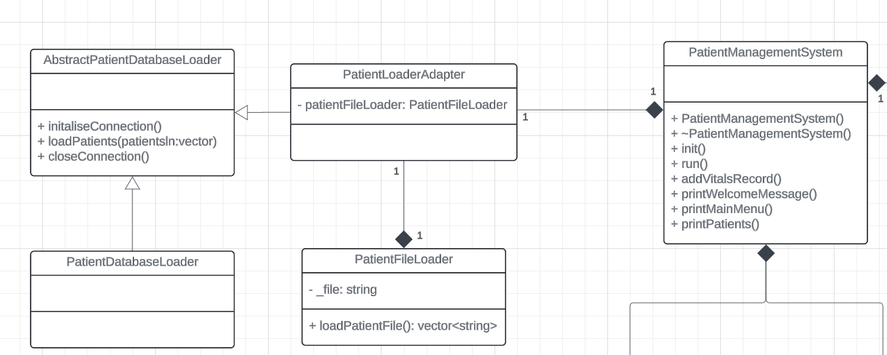

*Figure 3: adapter design pattern*

They system requirements have changed, so that instead of loading patient data from a database, patient data will instead be loaded from files. The underlying database system heavily interacts with the PatientManagementSystem, to be able to implement a system that loads patient files without affecting the PatientManagementSystem or PatientDatabaseLoader, I applied the adapter design pattern which creates an adapter that converts the interface of the AbstractPatientDatabaseLoader to one that PatientFileLoader can utilise.

This design is represented in figure 3. The adapter design is represented in the PatientLoaderAdapter. This class interfaces with the PatientFileLoader and PatientManagementSystem, as well as inheriting from the AbstractPatientDatabaseLoader.

**How it works**

1. The PatientManagementSystem initialises the PatientLoaderAdapter on class initialisation
2. The PatientManagementSystem will call loadPatients() inside its init() function, passing in a vector which will be loaded with patients
3. PatientLoaderAdapter initialises a reference to PatientFileLoader which is stored in patientFileLoader.
4. The PatientLoaderAdapter will call loadPatientFile() which returns a vector that contains pointers to instantiated patients
5. The vector will then be looped through to retrieve each patient pointer, adding them to the passed in vector

**Git commits:**

* The patient loader adapter was initially created in d06df11
* The adapter was finished, and a unique pointer was created to refer to the file loader class in 93f2835
* PatientFileLoader can successfully convert the data from the txt files into patient data in e290e7e
* PatientFileLoader and PatientLoaderAdapter were finished and could successfully create and store patient data in c39cd7f
* Other commits include: 714bd6c, 05c7957, 7becb52
* The first attempt at the solution commits include: 174b672, 4063902, 914753e, 74fc412

# Observer Pattern

The observer pattern was chosen, as it makes sense for an alert system to be flexible and scalable. This makes it so that new stakeholders can be added to the system easily.